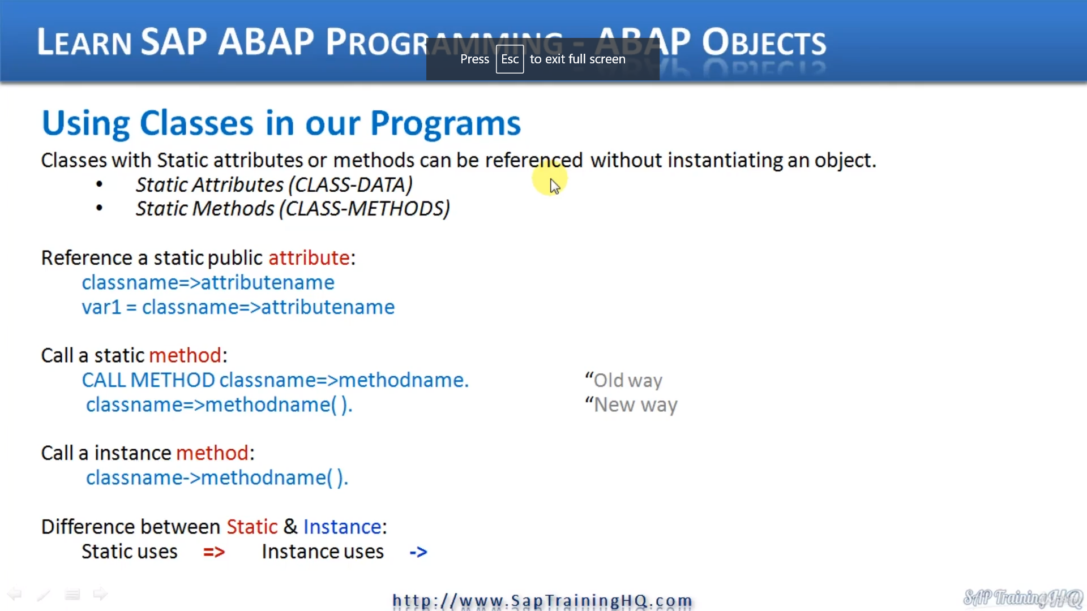

In this lesson, we're going to take a look at how we can reference attributes in our class and objects and also call methods of the objects we've created and actually methods of classes as well, because, as you know, we can create static attributes and static methods within our classes and we can use these static attributes and methods without having to instantiate objects.

Now, calling a static method is actually pretty similar originally when APAP Objects was first introduced, the way of calling methods and you'll see this in a lot of programs, you will see the call keyword.

So it used to be called method, and then we'd specify the class name. And again, we're using the equal sign and greater than sign and then we specify the method name.

An instance method, we use the - then the greater than sign. And here with opening closing brackets, there's no parameters to pass.

So just highlighted down here, the difference between static and instant's methods is static uses.

Equals sign the instance methods, for instance, uses the -.

So just to highlight the specific rules for calling methods we have designed.

There must not be a space before the opening parentheses, if we come down to this example here, you'll see that when we have the opening parentheses, there is no space at all.

There must be a space after the opening parentheses. So when we do want to pass a parameter or we're not passing any parameters at all, then we must at least have one space. And when we're passing parameters, we must have a space for either side of the parameters.

So let's have a look in a bit more detail down here. If a method imports more than one parameter, we list them out.

